

FALCULTY OF INFORMATION AND COMMUNICATION TECNOLOGY

PROG101: PRINCIPLES OF PROGRAMMING LOGIC AND DESIGN

Title : Designing Logical Solutions for Sierra Leone Community
Challenges
Issue Date : WEEK 2
Due Date : WEEK 4
Lecturer/Examiner : Mr Julius Laggah
Name of Student : David Edward Conteh Student ID No. : 905006509
Class : BIT
Semester/Year : 1 of 1
I hereby attest that contents of this attachment are my own work. Referenced works, articles, art, programs, papers or parts thereof are acknowledged at the end of this paper. This includes data excerpted from CD-ROMs, the Internet, other private networks, and other people’s disk of the computer system.

Student’s Signature : Date:

LECTURER’S COMMMENTS/GRADE: | for office use only upon receive  Remark  DATE :  TIME :  RECEIVER’S NAME :

Designing a Community Waste Management System for Jui, Sierra Leone

TABLE OF CONTENTS PAGE
1. Introduction and Problem Description 1
2. Background and Community Impact 2
3. Proposed Solution 3
4. Computational Thinking Process 4
5. Algorithm Design 5
6. Sustainable Development Goal (SDG) Alignment 8
7. Open-Source Software Justification 9
8. Digital Public Goods (DPGs) Justification 9
9. Algorithm 10
10. Pseudocode 11
11. Flowcharts 13
12. Functional Modules and Functions 17
13. Logical Design and Expected Outputs 18
14. GitHub Repository and Version Control Evidence 19
15. References 20

1

1.0 INTRODUCTION AND PROBLEM DESCRIPTION

1.1 Introduction
Waste management helps maintain clean surroundings, protect public health, and reduce pollution. I have personally noticed waste collection problems in Jui, Sierra Leone.
This project proposes a Community Waste Management System (CWMS) to record waste collection requests, identify their locations, and track their status using computational thinking, algorithms, pseudocode, flowcharts, and functions.

1.2 Problem Description
Waste collection problems may contribute to untidy surroundings, unpleasant smells, drainage blockages, and pollution. Keeping track of where waste needs collection and whether it has been collected can be difficult.
The proposed system will record the waste location, type, and request date. It will validate the information, generate a unique reference number, and assign a Pending status. Users can view pending requests and update them to Completed after collection.
The system will organize information but will not physically collect waste or guarantee collection services.

2.0 BACKGROUND AND COMMUNITY IMPACT

2.1 Background of the Community
Jui is selected because I have personally noticed waste collection problems in the area. This project focuses on recording waste requests and monitoring their status.

2.2 Impact of Waste Collection Problems
Waste collection problems may cause:
- Environmental impact: Pollution and drainage blockages.
- Public health impact: Unpleasant smells and possible pest attraction.
- Community appearance: Untidy shared spaces.
- Monitoring challenges: Difficulty identifying outstanding requests.
The extent of these effects in Jui would require further observation or research.

2.3 Importance of the Proposed System
The system will organize waste locations, types, request dates, and statuses. It could help users review pending requests and keep records of completed collection activities. Its usefulness will depend on accurate information and regular updates.

3.0 PROPOSED SOLUTION

3.1 Overview The Community Waste Management System (CWMS) is a proposed information system for recording and monitoring waste collection requests in Jui.

3.2 Main Features The system will:
- Record waste location, type, and request date.
- Validate required information.
- Generate a unique reference number.
- Assign new requests a Pending status.
- Display pending requests.
- Allow authorized users to mark requests Completed after collection.
- Display request details and status.

3.3 How the System Works The system will display a menu for recording requests, viewing pending requests, updating statuses, or exiting. When a request is submitted, the system will validate the information. If complete, it will generate a reference number, save the request as Pending, and display confirmation. Users can view pending requests or search by reference number. After collection, an authorized user can update the request to Completed. The menu repeats until Exit is selected.

3.4 Benefits and Limitations The system could organize waste collection information, identify outstanding requests, and maintain completed-request records.However, it cannot physically collect rubbish or guarantee collection. Its effectiveness depends on accurate data, regular updates, and responsible users. It is currently a logical design proposal.

4.0 COMPUTATIONAL THINKING PROCESS
Computational thinking helps solve problems by breaking them into tasks, identifying patterns, focusing on important information, and developing logical instructions.

4.1 Decomposition
The system is divided into smaller tasks: recording requests, validating information, generating reference numbers, viewing pending requests, and updating statuses.

4.2 Pattern Recognition
Each request contains common information: location, waste type, date, reference number, and status. This consistent structure makes requests easier to record and display.

4.3 Abstraction
The system focuses on necessary information—location, waste type, date, reference number, and status—while excluding unrelated details.

4.4 Algorithmic Thinking
The system follows logical steps: collect information, validate it, generate a reference number, save the request, and assign a status. It also allows users to view and update requests.

4.5 Importance of Computational Thinking
Computational thinking organizes the system's tasks and supports the development of algorithms, pseudocode, flowcharts, and functions.

5.0 ALGORITHM DESIGN

5.1 Introduction
An algorithm is a step-by-step set of instructions used to solve a problem. The CWMS algorithm explains how requests are recorded, assigned reference numbers, displayed, and updated.

5.2 Main Algorithm
- Start the system.
- Display the main menu.
- Ask the user to select an option.
- If Record Request is selected, collect the location, waste type, and date.
- Validate the information.
- If information is missing, display an error and request the missing details.
- If complete, generate a unique reference number.
- Save the request with Pending status.
- Display confirmation and the reference number.
- If View Pending Requests is selected, display pending requests.
- If Update Request Status is selected, ask for the reference number and search.
- If found and collection has taken place, update the status to Completed.
- If not found, display an error.
- If an invalid option is selected, display an error.
- Return to the menu until Exit is selected.
- Stop.

5.3 Recording a Request
- Enter waste location, type, and request date.
- Check that all required information is complete.
- If information is missing, display an error and request correction.
- If complete, generate a unique reference number.
- Save the request and assign Pending status.
- Display confirmation and the reference number.
- Stop.

5.4 Reference Number Generation
Each valid request receives a unique reference number using the prefix CWMS and sequential numbering.
Examples:
- CWMS-001
- CWMS-002
- CWMS-003
The number increases for each valid request and is generated only after information is validated.

5.5 Viewing Pending Requests
- Retrieve recorded requests.
- Check each request's status.
- Display the reference number, location, waste type, and date for Pending requests.
- If none exist, display “No pending requests.”
- Stop.

5.6 Updating Request Status
- Enter the request reference number.
- Search for the request.
- If not found, display an error.
- If found, display its details and status.
- Confirm whether waste has been collected.
- If collected, change status to Completed.
- Save the update and display confirmation.
- Stop.

5.7 Conclusion
The algorithms explain how the system validates and records requests, generates reference numbers, displays pending requests, and updates statuses. They form the foundation for the pseudocode and flowcharts.

6.0 SDG ALIGNMENT

6.1 Sustainable Development Goal 11(Sustainable Cities and Communities)
The project aligns with SDG 11: Sustainable Cities and Communities, which focuses on inclusive, safe, resilient, and sustainable communities.
The system can record waste locations and monitor pending or completed requests. This information could help residents and authorized waste personnel organize waste collection activities and support a cleaner community in Jui.
However, the system does not physically collect waste or guarantee collection services.

6.2 Sustainable Development Goal 12(Responsible Consumption and Production)
The proposed Community Waste Management System (CWMS) also aligns with Sustainable Development Goal 12 (SDG 12): Responsible Consumption and Production. This goal promotes responsible use of resources and reducing waste.
The system will allow users to record waste collection requests, identify waste locations, and monitor pending and completed requests. By organizing waste information, it could help community members and authorized waste management personnel manage reported waste problems more effectively.
The proposed system could support responsible waste management practices in Jui, Sierra Leone. However, it does not directly reduce waste or physically collect rubbish. Its contribution is to organize and monitor waste collection requests.

7.0 OPEN-SOURCE SOFTWARE JUSTIFICATION

7.1 Why the System Could Be Open Source The CWMS could be developed as open-source software, allowing people to study, use, and improve its design and source code.

7.2 Benefits in Sierra Leone Open-source software could encourage local technology development, learning, collaboration, and adaptation. Other communities could use the system's design for similar waste management challenges.

7.3 Community Contribution Students, developers, and community organizations could suggest improvements, review the design, identify errors, and improve documentation.
The CWMS is currently a logical design proposal, not a completed open-source application.

8.0 DIGITAL PUBLIC GOODS JUSTIFICATION

8.1 Public Benefit
The proposed CWMS could help people in Jui report waste problems, record locations, and monitor collection requests.
Organized information could improve communication between residents and authorized waste management personnel.

8.2 Contribution to Community Development The system could make waste reporting more organized and help authorized personnel identify pending and completed requests. Its design could also be adapted by other communities.
However, it cannot physically collect waste or guarantee that reported problems will be resolved.
9.0 ALGORITHM: COMMUNITY WASTE MANAGEMENT SYSTEM
- Start the system.
- Display the main menu:
  - Record a waste collection request.
  - View pending requests.
  - Update request status.
  - Exit.
- If Record Request is selected:
  - Enter location, waste type, and request date.
  - Validate the information.
  - If incomplete, display an error.
  - If complete, generate a unique reference number.
  - Save the request as Pending.
  - Display confirmation.
- If View Pending Requests is selected:
  - Display all pending requests.
  - If none exist, display a message.
- If Update Request Status is selected:
  - Enter and search for the reference number.
  - If found and collection has taken place, update status to Completed.
  - If not found, display an error.
- If Exit is selected, display an exit message and stop.
- If an invalid option is selected, display an error.
- Repeat the menu until Exit is selected.
- End the system.

10.0 PSEUDOCODE

10.1 Main System
BEGIN

REPEAT
DISPLAY main menu
INPUT choice

IF choice = 1 THEN
CALL RecordRequest

ELSE IF choice = 2 THEN
CALL ViewPendingRequests

ELSE IF choice = 3 THEN
CALL UpdateRequestStatus

ELSE IF choice = 4 THEN
DISPLAY "Exiting the system"

ELSE
DISPLAY "Invalid option"
END IF

UNTIL choice = 4

END

10.2 Record Request
PROCEDURE RecordRequest

INPUT waste location
INPUT waste type
INPUT request date

IF information is missing THEN
DISPLAY "Complete all required information"
ELSE
GENERATE reference number
SAVE request
SET status to Pending
DISPLAY "Request recorded successfully"
END IF

END PROCEDURE

10.3 View Pending Requests
PROCEDURE ViewPendingRequests

SEARCH pending requests

IF requests exist THEN
DISPLAY pending requests
ELSE
DISPLAY "No pending requests"
END IF

END PROCEDURE

10.4 Update Request Status
PROCEDURE UpdateRequestStatus

INPUT reference number
SEARCH for request

IF request is found THEN

IF waste has been collected THEN
SET status to Completed
DISPLAY "Status updated"
ELSE
DISPLAY "Request is still pending"
END IF

ELSE
DISPLAY "Request not found"
END IF

END PROCEDURE

11.1 Main System Flowchart

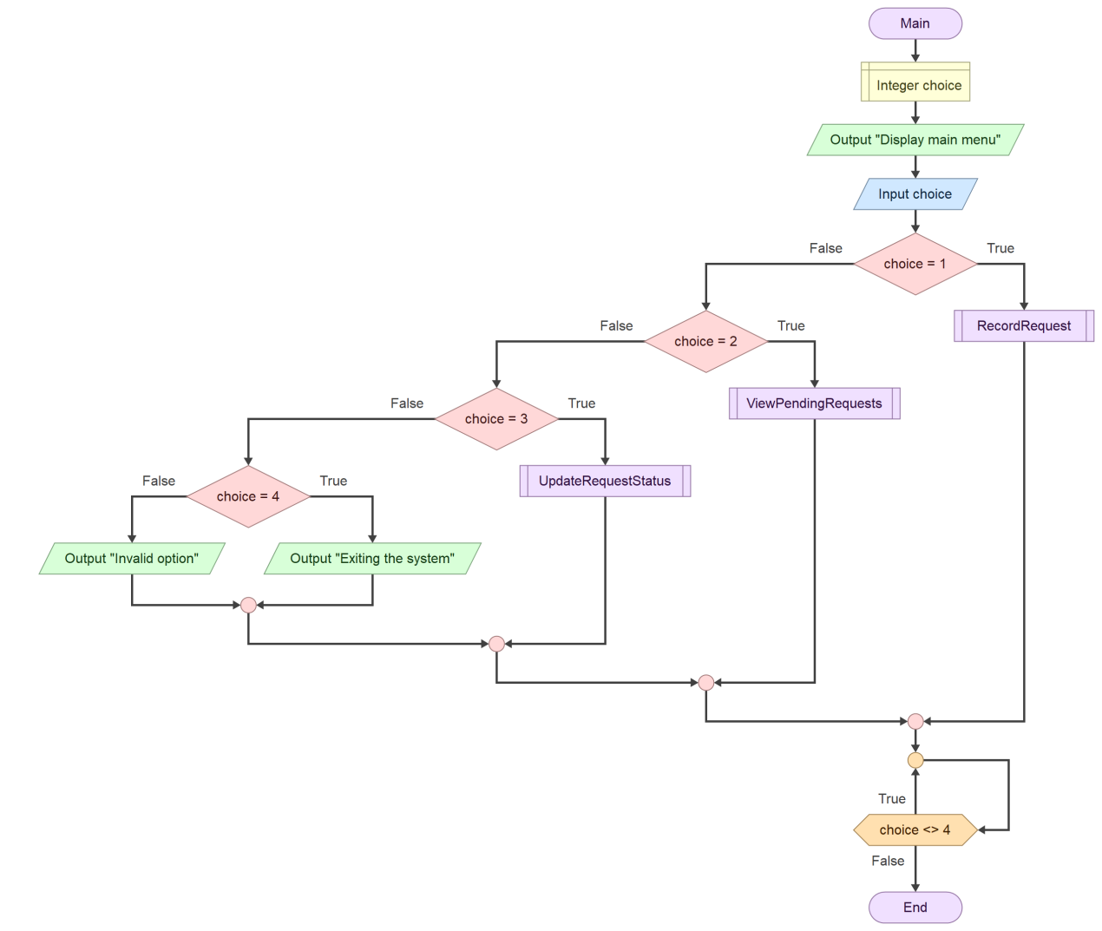

11.2 Record a Waste Request

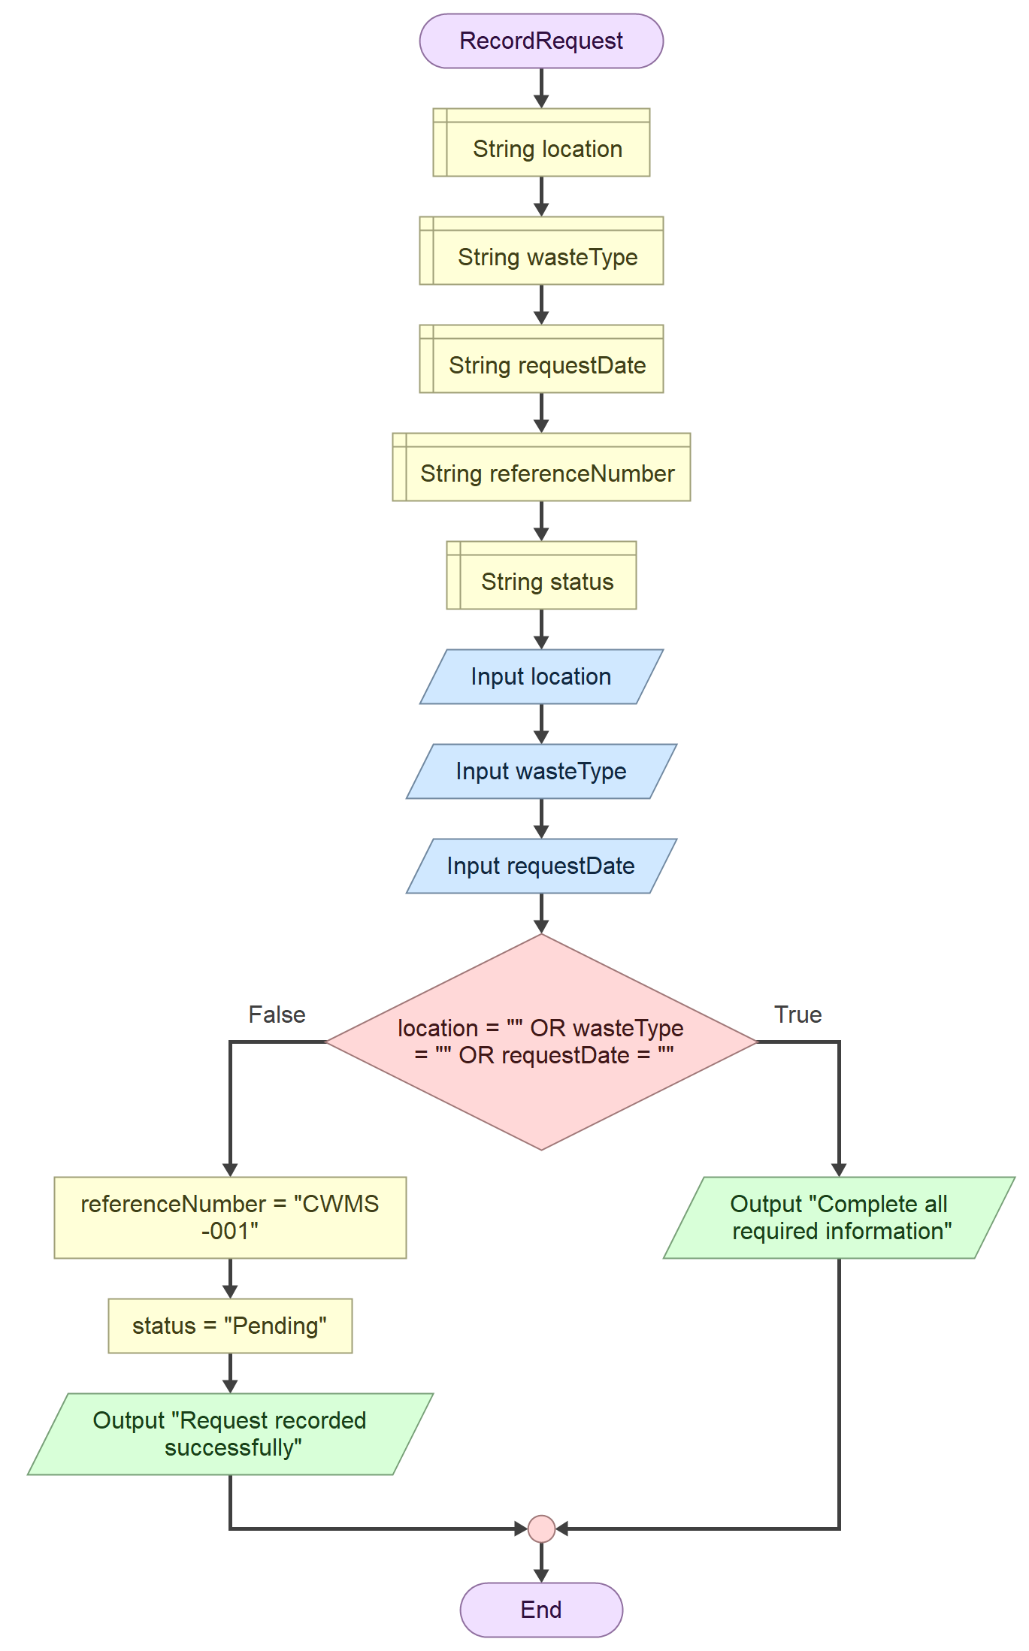

11.3 View Pending Requests

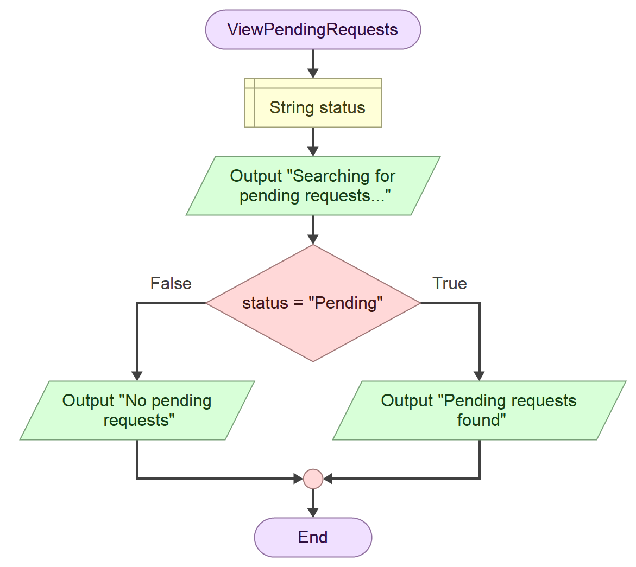

11.4 Update Request Status

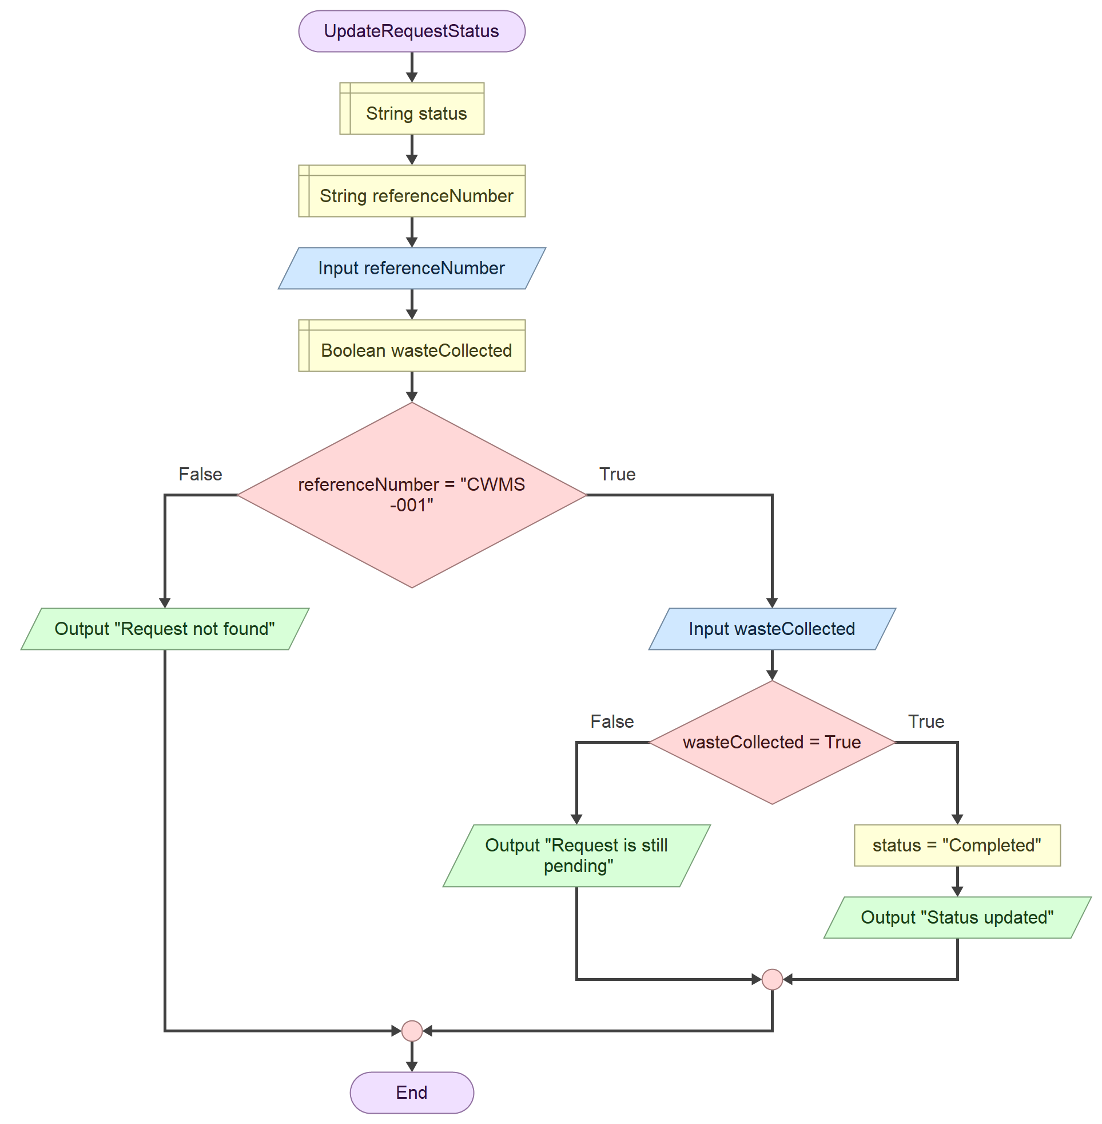

12.0 FUNCTIONAL MODULES AND FUNCTIONS
The Community Waste Management System is divided into different functional modules. Each module performs a specific task to make the system easier to use and manage.
12.1 Main Menu
The main menu allows users to choose the operation they want to perform. It provides options to record a new waste request, view pending requests, update a request status, or exit the system.
12.2 RecordRequest
This function allows users to submit a new waste request by entering the location, type of waste, and request date. The system checks that all required information has been provided. If the information is complete, it generates a reference number and sets the request status to Pending.
12.3 ViewPendingRequests
This function allows users to view waste requests that are still pending. It checks for pending requests and displays them when available. If there are no pending requests, the system displays a message informing the user.
12.4 UpdateRequestStatus
This function allows an existing waste request to be updated. The user enters the request reference number. If the request is found and the waste has been collected, the system changes its status from Pending to Completed. Otherwise, it displays an appropriate message.

13.0 LOGICAL DESIGN AND EXPECTED OUTPUTS The Community Waste Management System follows a series of steps to process waste requests. Users interact with the system through a main menu, where they can record a new request, view pending requests, update request statuses, or exit the system.
13.1 Logical Design
The system begins by displaying the main menu. The user selects an option, and the system performs the selected operation.
When a new waste request is recorded, the system collects the location, type of waste, and request date. It checks that all required information has been entered. If the information is complete, the system generates a reference number and sets the request status to Pending.
Users can also view pending requests. When updating a request, the system checks the reference number and whether the waste has been collected. If the waste has been collected, the status changes to Completed.
13.2 Expected Outputs
The system is expected to display the following messages and results:
- Successful request: "Request recorded successfully" and a reference number.
- Missing information: "Complete all required information".
- Pending requests: "Pending requests found".
- No pending requests: "No pending requests".
- Successful status update: "Status updated".
- Waste not collected: "Request is still pending".
- Invalid reference number: "Request not found".
- Exit: "Exiting the system". These outputs help users understand the result of each operation and make the system easier to use.

14.0 GITHUB REPOSITORY AND VERSION CONTROL EVIDENCE
GitHub is an online platform used to store, manage, and share project files. For this project, GitHub is used to keep the files and evidence related to the Community Waste Management System for Jui, Sierra Leone.
A repository was created on GitHub using the required naming format, which includes the course code, assignment number, student name, and student ID. A README file was also created to provide information about the project, its purpose, and the technologies used.
GitHub will be used to store the project documentation, pseudocode, Flowgorithm flowcharts, and other assignment evidence as the project progresses.
Version control helps keep track of changes made to project files. It also makes it easier to manage updates and maintain an organized record of the work.
Repository Link: https://github.com/edwardcontehdavid4-spec/PROG101-Assignment-1-David-Edward-Conteh-905006509

Evidence
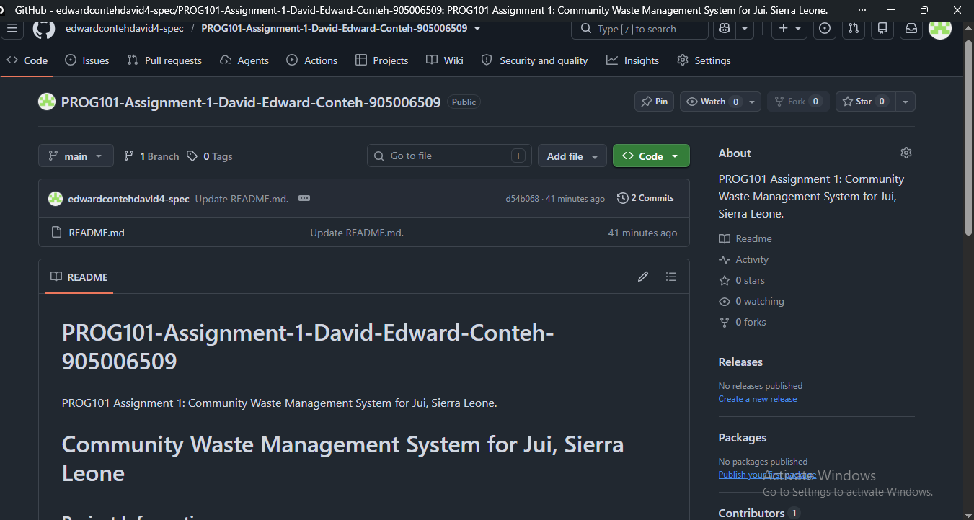

15.0 REFERENCES
Digital Public Goods Alliance (n.d.) Digital Public Goods. Available at: https://digitalpublicgoods.net/ (Accessed: 3 November 2026).
GitHub (n.d.) GitHub Documentation. Available at: https://docs.github.com/ (Accessed: 3 November 2026).
Open Source Initiative (n.d.) The Open Source Definition. Available at: https://opensource.org/osd (Accessed: 3 November 2026).
United Nations (n.d.) Goal 11: Sustainable Cities and Communities. Available at: https://sdgs.un.org/goals/goal11 (Accessed: 3 November 2026).

